One Page

Mixed Runner

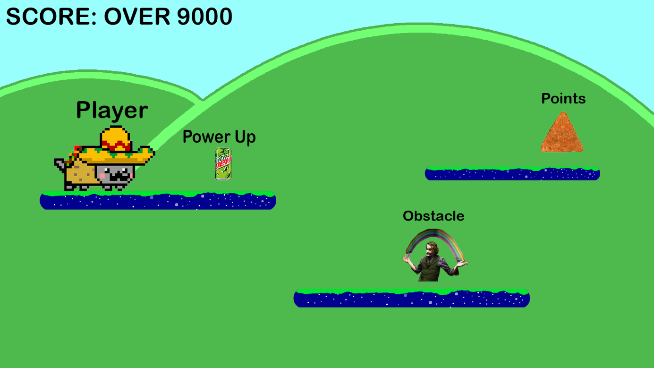

|  |  |
| --- | --- |
| Controls | A,W,S,D SpaceBar |
| Enemy’s | Gif’s and Meme’s |
| Obstacled | Poorly Edited pictures |
| Power Up’s | Speed or jump boost and shield |

Description

Basically we just take memes and shit and create the best game is over meme